**Before using the tool please save the “PrizyPricer” file to location E:/ attached in mail**

**1.Client Interface**

To add product price

Enter the product detials and price then click submit

Note : Product code has to be entered manully.

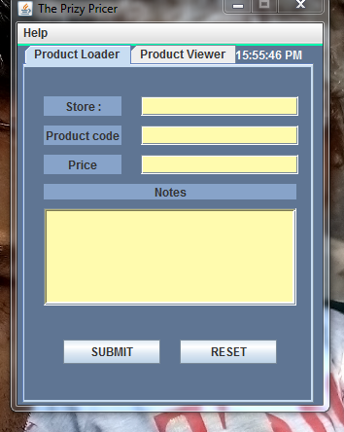

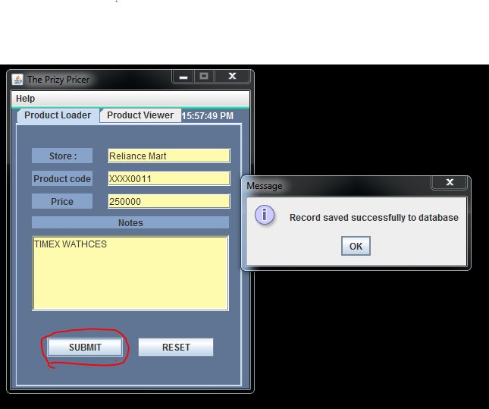

**2. Admin panel**

To view the specific product and its details

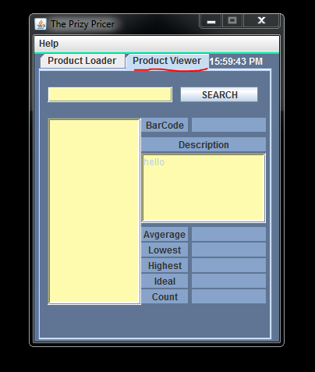

2.Enter the product name to search, Its wild card serach on clicking SEARCH button you will see the list of product in product list.

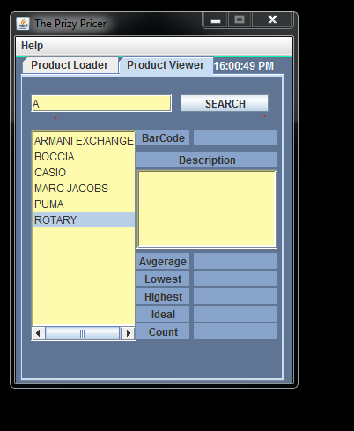

3.To get the rest of product details , Double click the product names form the product list

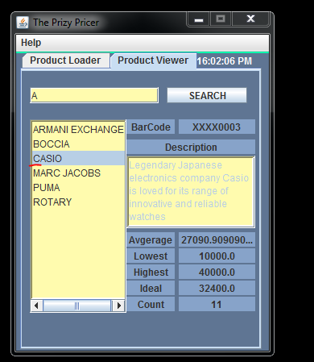

1. Product_master_details Table

The product first needed to be added in master list (mannually) , So that you can display the project details

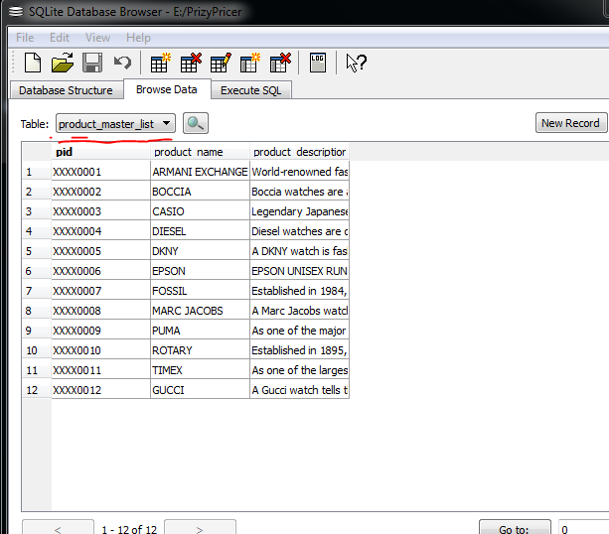

1. Price_loader table

The data enter by client will be saved in this table

